

**Общественное объединение**

**“Реабилитационно-развивающий центр “Страна чудес”**

БИН 190140030517, Адрес: 070009, Республика Казахстан,

г.Усть-Каменогорск, ул. Бажова, 348.

Тел.: 87776650570, 87779956820

Сайт: [www.stranachudes.kz](http://www.stranachudes.kz) Инстаграм: strana_chudes_ukg,

e-mail mamburovaliliya@rambler.ru

**Charity project “Little Miracle”**

**with the support of the EBRD**

**Final report**

**Period: September 2022 - September 2023**

**Amount to be disbursed:**

From the first of September 2022, 17 children with special educational needs (SEN), including 12 disabled children, from families in difficult life situations, had the opportunity to undergo a full annual rehabilitation course at the institution “Special School - Kindergarten “Strana Chudes” "for children with ASD." The center uses modern and effective methods, as well as its own curriculum. For all children, a primary diagnosis was carried out and an individual rehabilitation program (IRP) was drawn up.

Nine children attend a correctional kindergarten. They are divided into groups according to age and skill level. As part of group classes, children develop communication skills, learn the basics of literacy and mathematics, and the Kazakh language. Children are offered cooking lessons, music and rhythm classes, adaptive physical education classes, and creative activities. Every day our students study in the sensory integration room.

Five children attend a primary correctional school. As part of the curriculum, children study: mathematics, primer, the basics of the world around them, the Kazakh language, digital literacy, and also engage in music, physical education, and attend various creative clubs. In January and June, all children completed 2 health courses to strengthen the immune system by visiting a salt cave. One course consisted of 10 sessions.

Two children attend the center 3 times a week as part of individual lessons; due to their physical characteristics, they are not able to attend group classes; specialists work with the children: a psychologist, a speech pathologist, and a sensory integration specialist. In addition, children attend classes in the pool 2 times a week and have completed a course of halotherapy: 10 sessions.

In addition to group classes, all beneficiaries receive daily individual correctional classes in accordance with the IPR. The following people work with children in individual lessons: psychologists, speech pathologists, speech therapists, an exercise therapy instructor, a sensory integration specialist; children visit the pool 2 times a week.

The project had a positive public response. In addition to the actual assistance provided to children within the framework of the project, the public association continued to raise funds for an account opened for the project in support of children in need of rehabilitation. This made it possible to reach a larger number of children and to continue to provide assistance to children after the completion of the project.

By decision of the meeting of the founders of the NGO "Rehabilitation and Development Center " Strana Chudes " with the support of the partner organization "Special School - Kindergarten " Strana Chudes ", it was decided to continue the course of correction and rehabilitation on a charitable basis for the thirteen children:

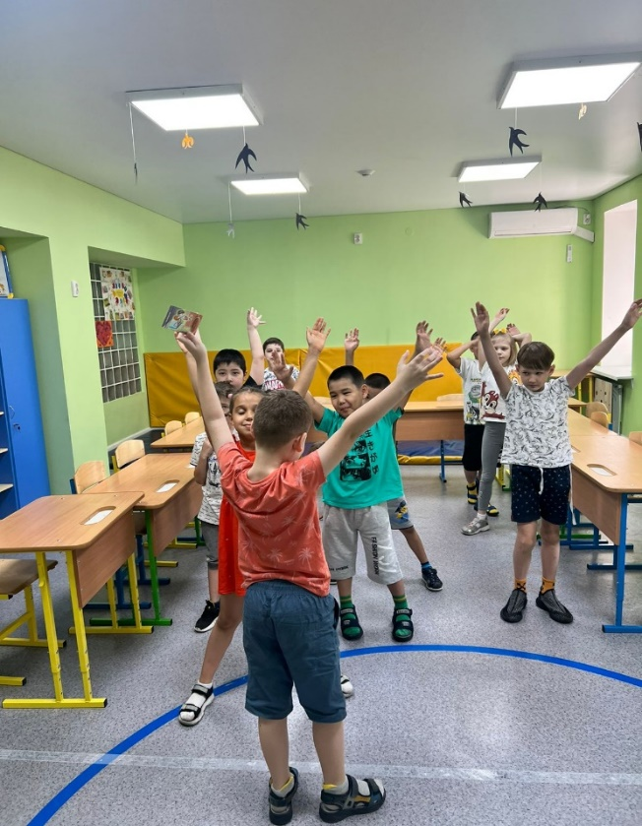 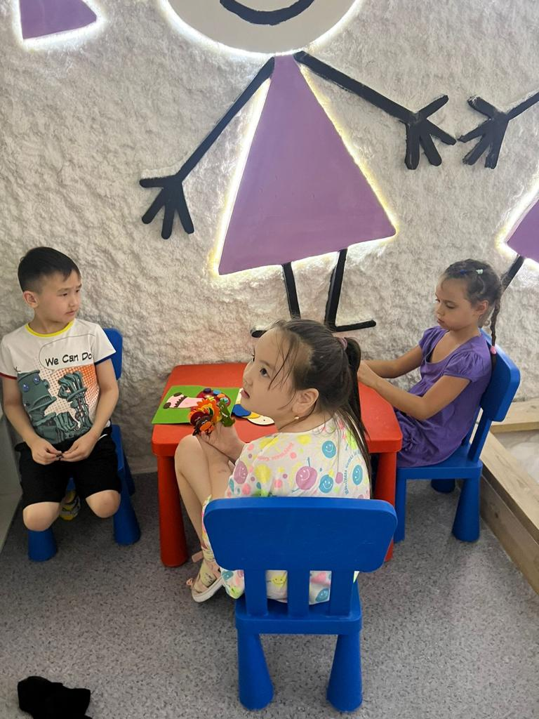

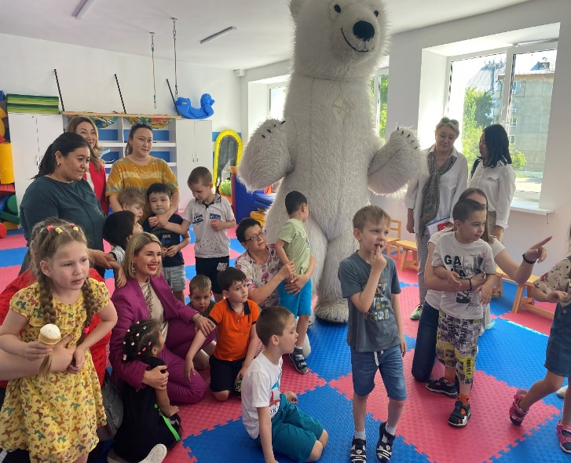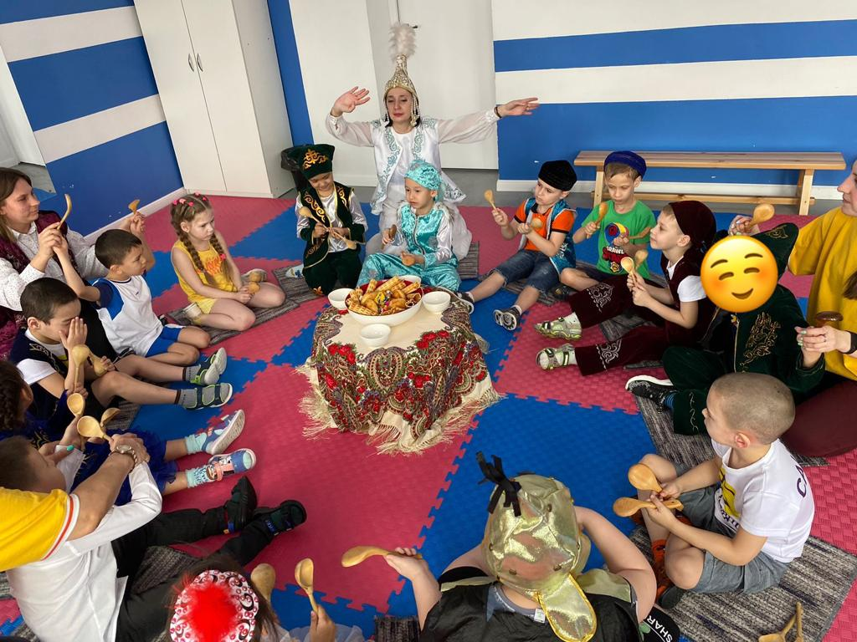

**OUR BENEFICIARIES:**

**Brothers Islam A. (8 years old) and Edil A. (9 years old)**

Islam and Edil are brothers; both boys have autism. The boys' mother is very grateful for the opportunity to visit the center free of charge. Islam attended the kindergarten group, and in September 2023 the boy went to the first grade of the “Wonderland Special School-Kindergarten” for home-based education under an individual correctional program. Yedil moved to second grade in September 2023, the boy has seen great progress in his skills over the past year, his speech, counting and writing skills have improved, the boy began to feel more confident in the team, and is making friends with his classmates.

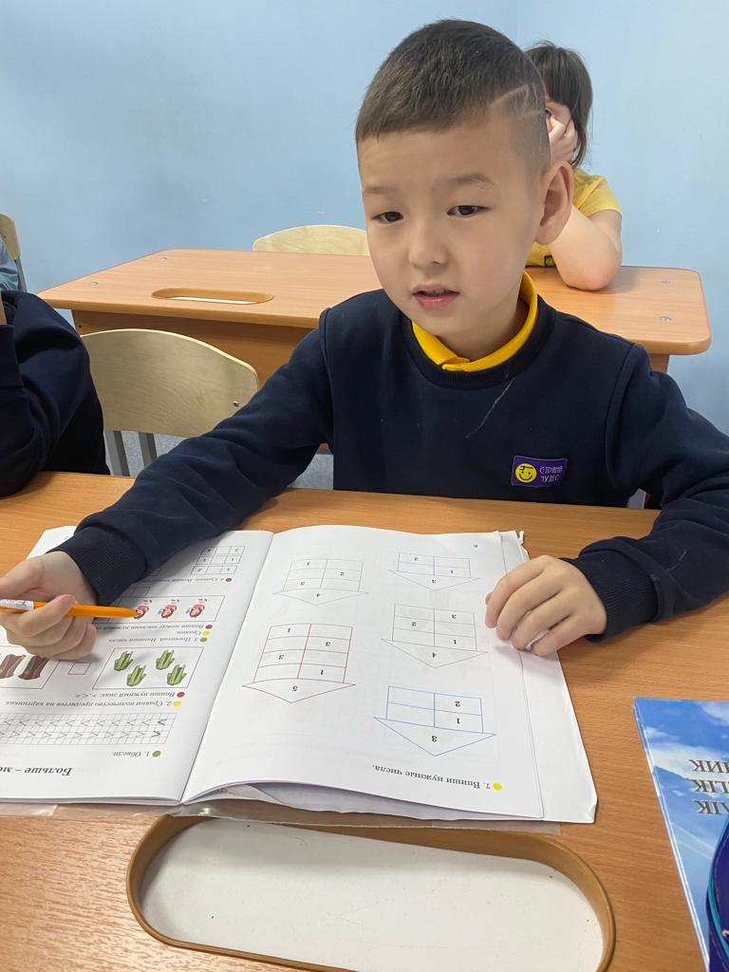 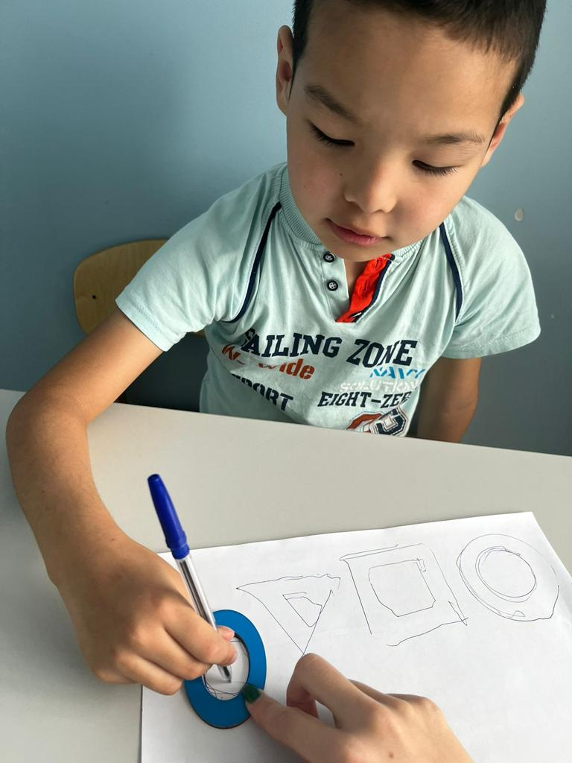 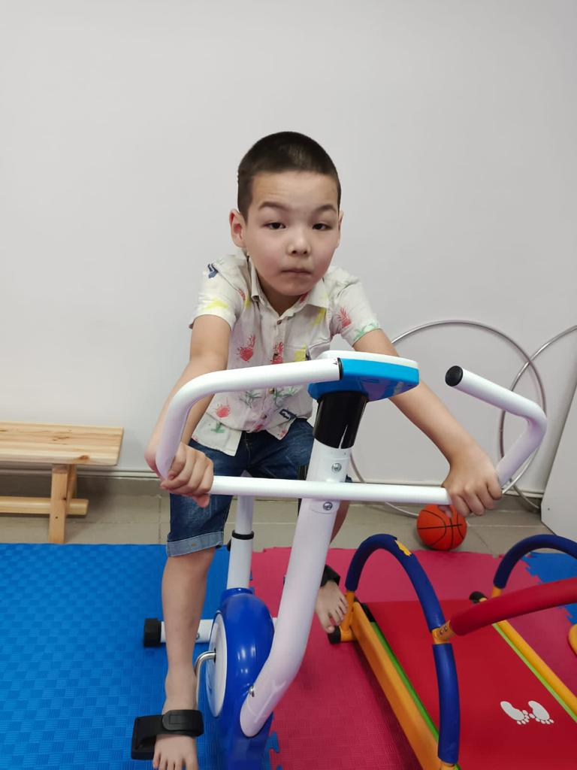

**Brothers Maxim S. and Nikita S. (7 years old)**

Maxim and Nikita were born as triplets, one of the brothers attends a regular kindergarten, and two boys need rehabilitation. The boys have been attending the Wonderland kindergarten for the second year now and in September 2023 they entered grade zero. Today, with regular visits and classes with specialists, great progress in the development of children is visible. The center has an individual approach to each child and its own teaching methods. During the visit, Nikita began to speak a little, follow instructions, knows numbers, the alphabet, can determine more than less, assembles sorters, knows the sequence well, and has become diligent in class. Maxim began to partially understand speech, learned to recognize animals by sounds and pictures, assemble sorters, draws well, makes crafts, and became diligent in class.

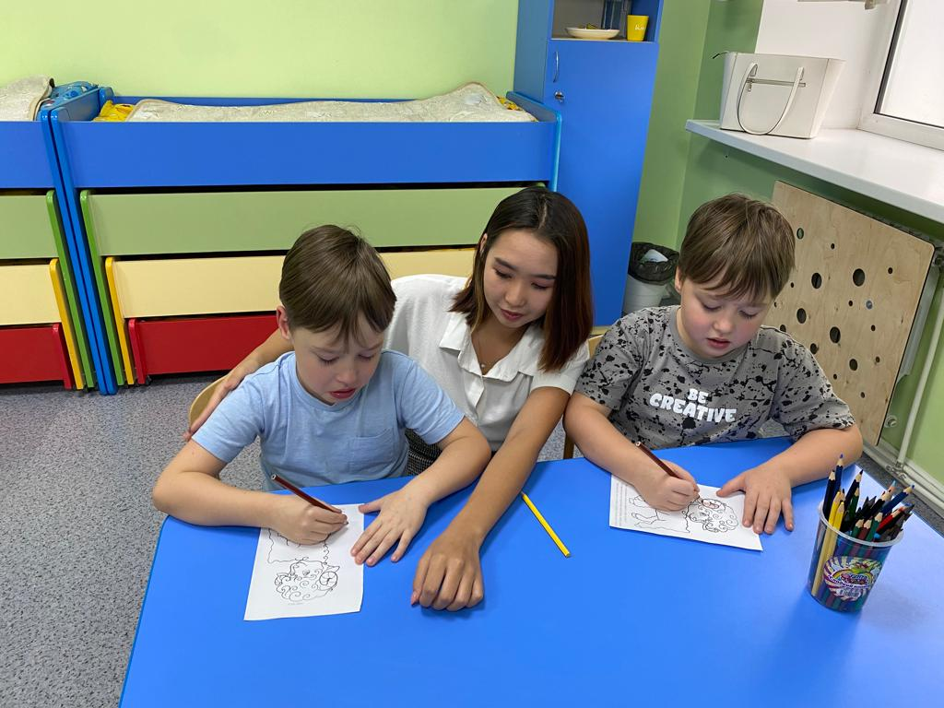 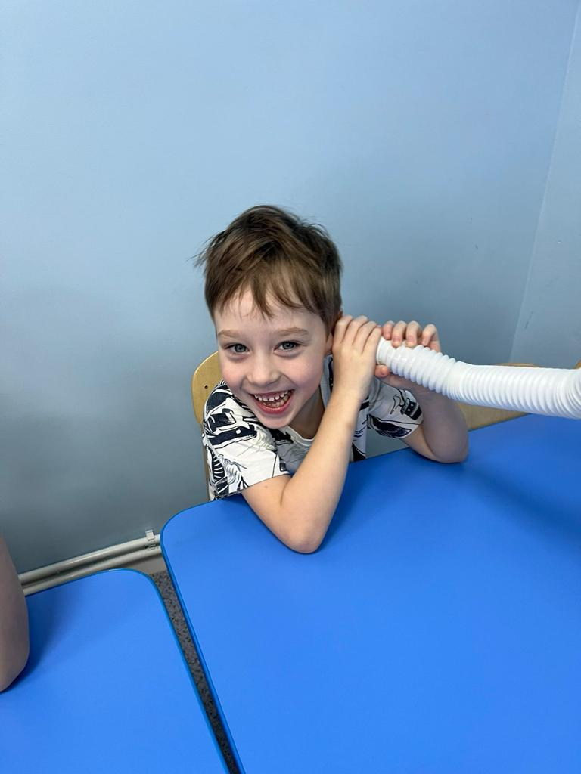 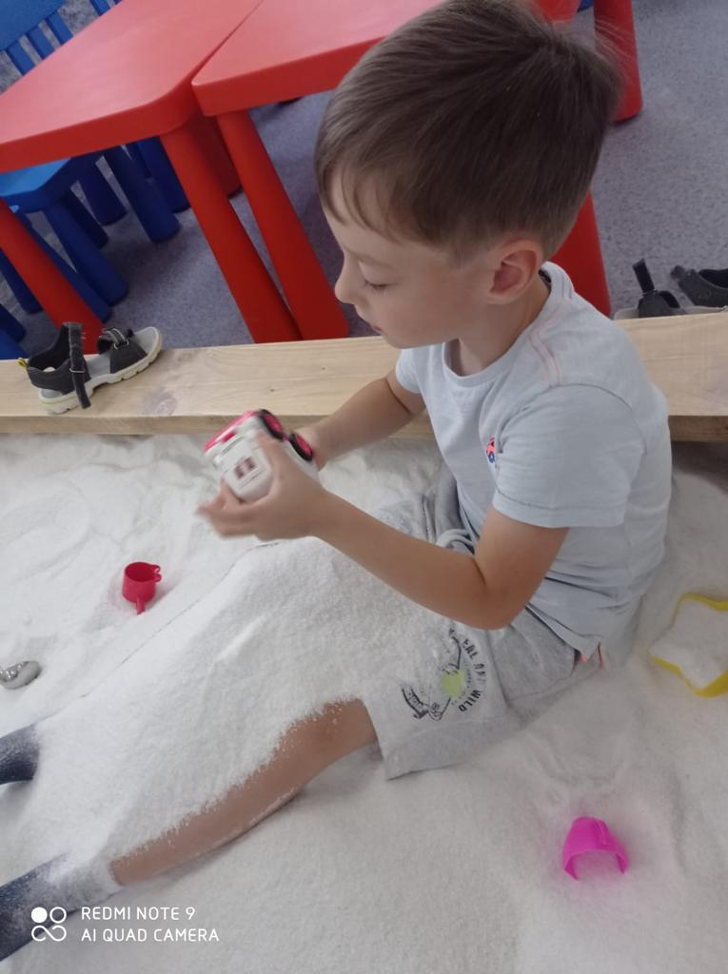

**Brothers Daryn D. and Damir D. (9 years old)**

Daryn and Damir are twin brothers, the boys have autism spectrum disorder. In September 2022 they went to school, 1st grade. The boys really enjoy learning, they enjoy studying in class and make great progress. Damir's hysterics went away and he began to understand speech better. Daryn began to say that the boys are doing well in the school curriculum and are mastering academic skills: reading, writing, mathematics. They love to exercise in the pool and in the sensory integration room.

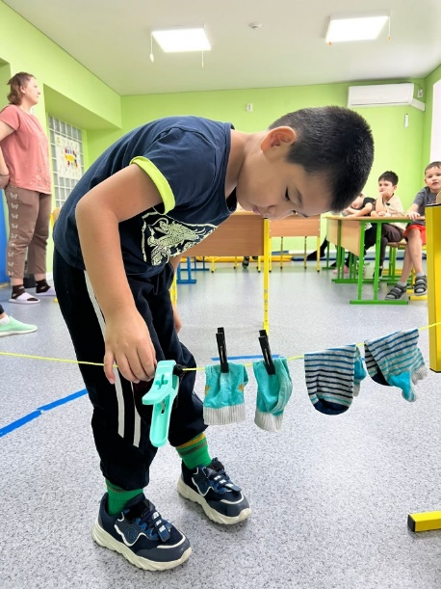 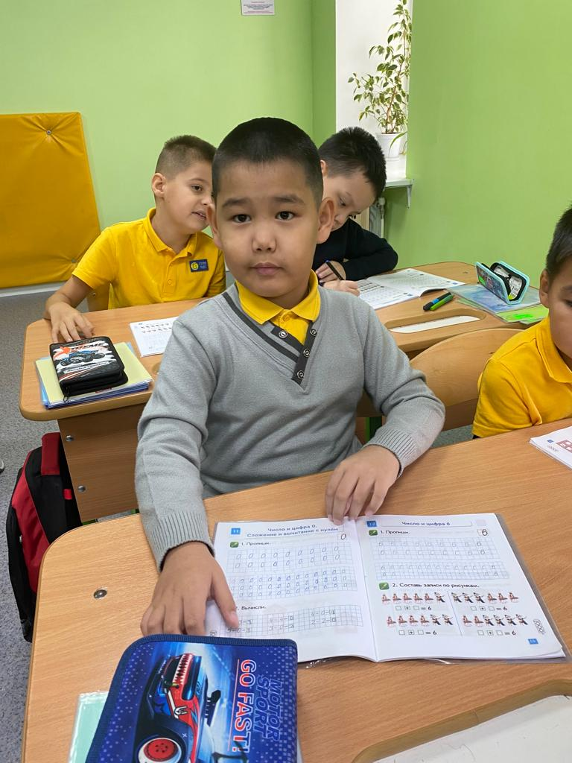 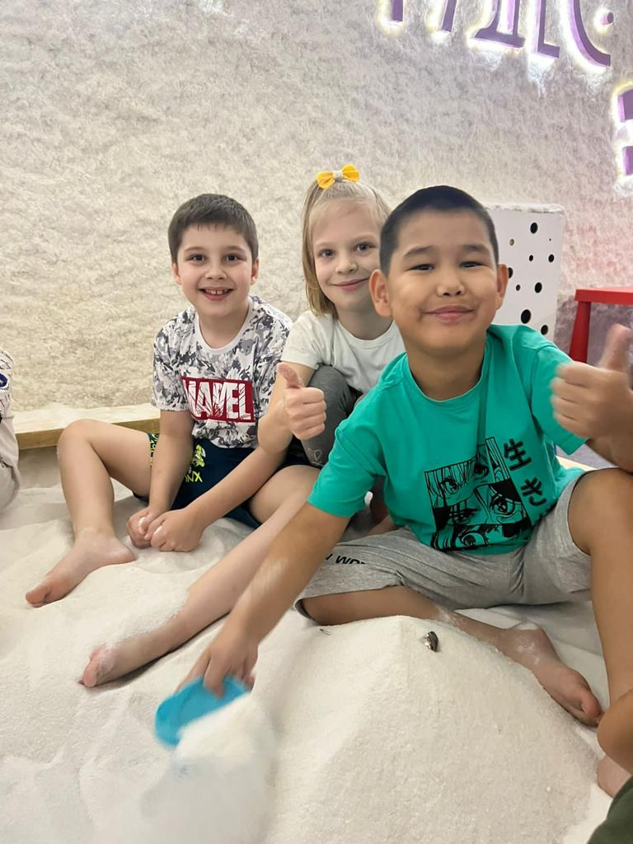

**Brother and sister Matvey S. (6 years old) and Lisa S. (5 years old)**

Matvey and Lisa are brother and sister; both children suffer from autism. They went to kindergarten for the first time since September 2022. The mother contacted the center when she noticed that the children were lagging behind in development. Matvey had behavioral problems, hyperactivity and attention deficit disorder. Lisa was very afraid of people and society. The daughter is no longer afraid of people, she goes to the garden with pleasure, the son has become more obedient, and he also goes to the garden with joy. Since the age of 4, Matvey has known numbers up to 100, counted in his head to 10, knows letters in Russian and English and tries to write them, knows colors in Russian and English, and geometric shapes of animals. Lisa learned to sit at the table and study.

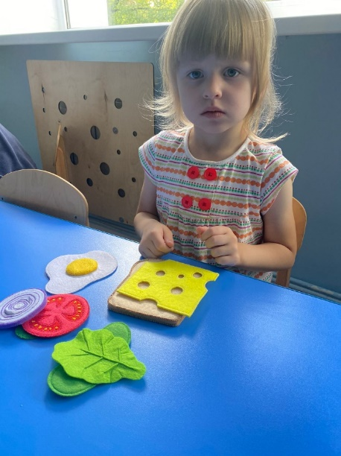 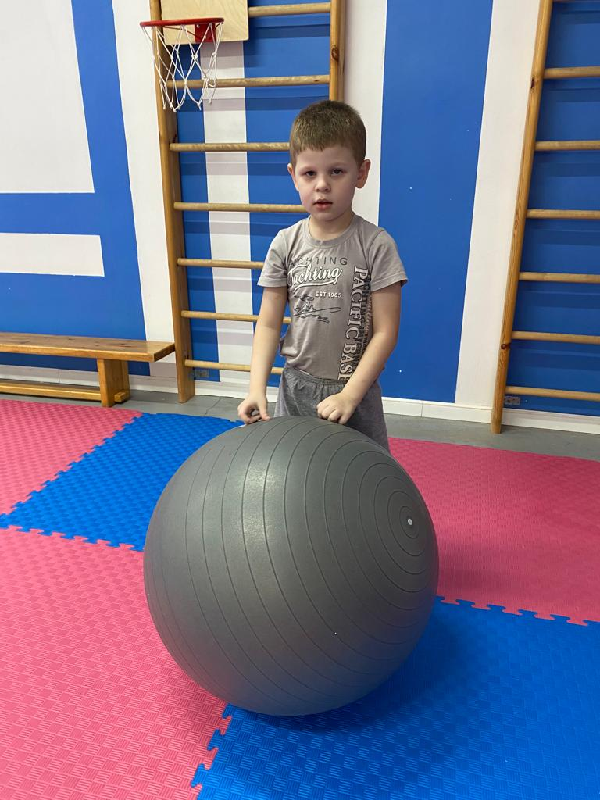 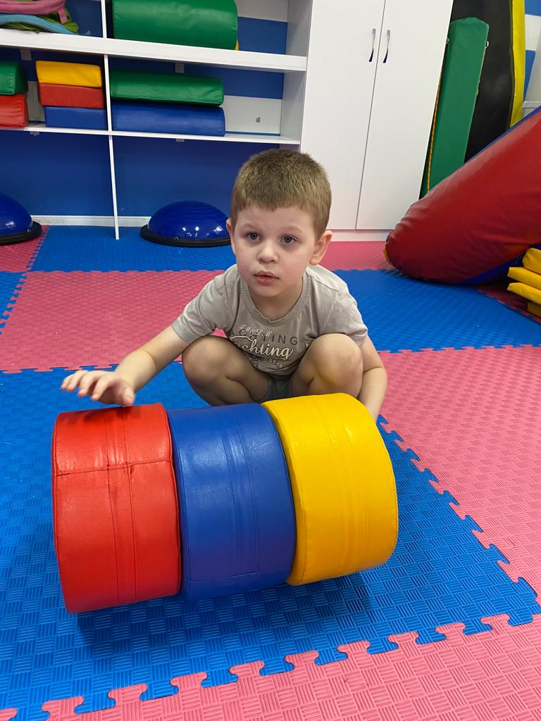

**Kamalia S. (8 years old)**

On September 1, 2022, Kamalia went to first grade. The girl is very diligent, follows the teacher’s instructions, and loves to color, draw, and put together puzzles. Kamaliya has made noticeable progress in her development. In September 2023, Kamaliya entered the second grade of a comprehensive school with a tutor.

|  |  |
| --- | --- |
| C:\Users\User\Desktop\фото для отчета\Сембай Камалия\IMG-1188.jpg | C:\Users\User\Desktop\фото для отчета\Сембай Камалия\9578fd86-0ec7-48d6-a9f5-70cbf81399ca.JPG |
| C:\Users\User\Desktop\фото для отчета\Сембай Камалия\249f4abf-f743-42fd-a74a-567dc5dbf262.JPG |

**Jasmine J. (9 years old)**

Jasmine is the second special child in the family. Jasmine has been attending the center since September 2022. On December 1, 2022, she was transferred to 1st grade. Before they came to the center, Jasmine did not know how to write or repeat words. I repeated some sounds. During this school year, Jasmine learned to write, repeat syllables, began to repeat more sounds, and her understanding improved. I began to color the drawings in detail and carefully. She is changing before our eyes for the better. By the way, I started typing at the computer the names of the months, the names of my favorite cartoons, my favorite treats, my last and first names, my sister’s name and much more. All these skills and more appeared during the school year. From September 2023, Jasmine moved to the second grade of a comprehensive school with a tutor.

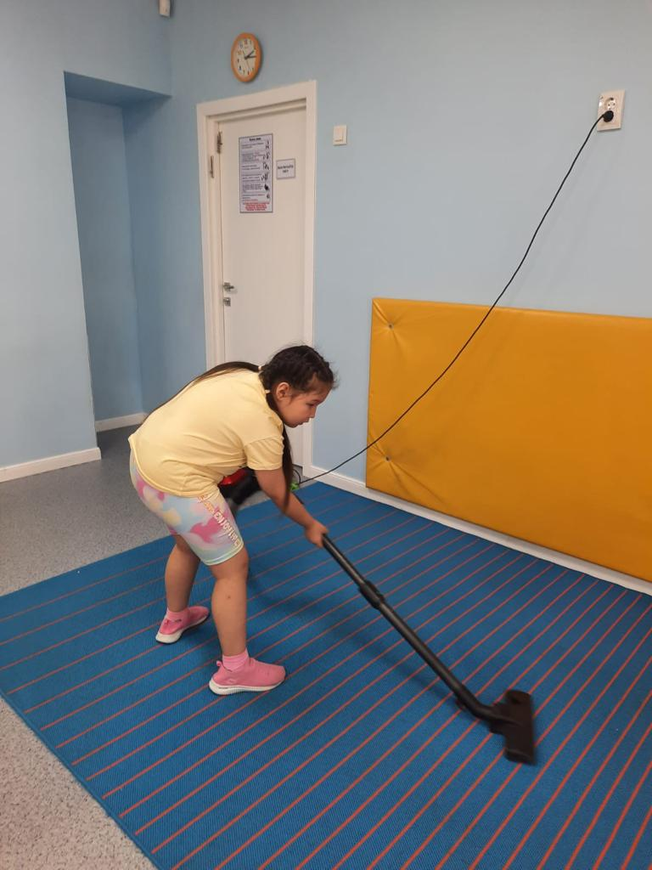 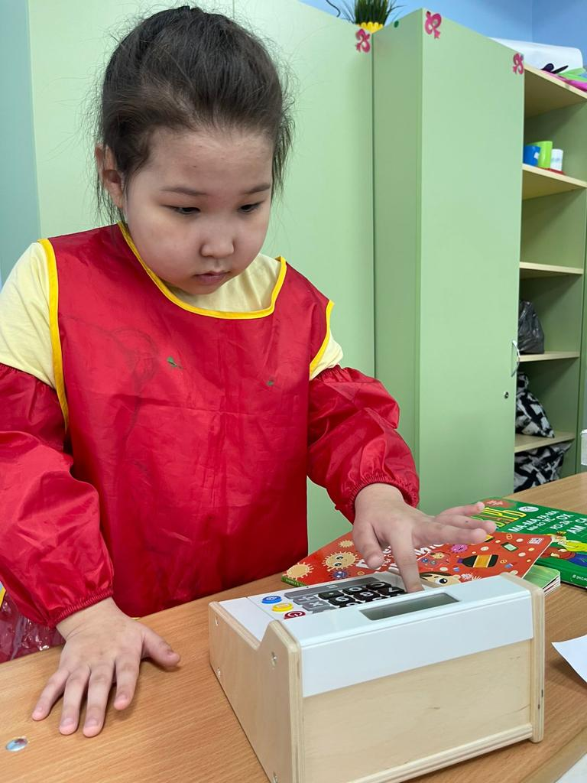 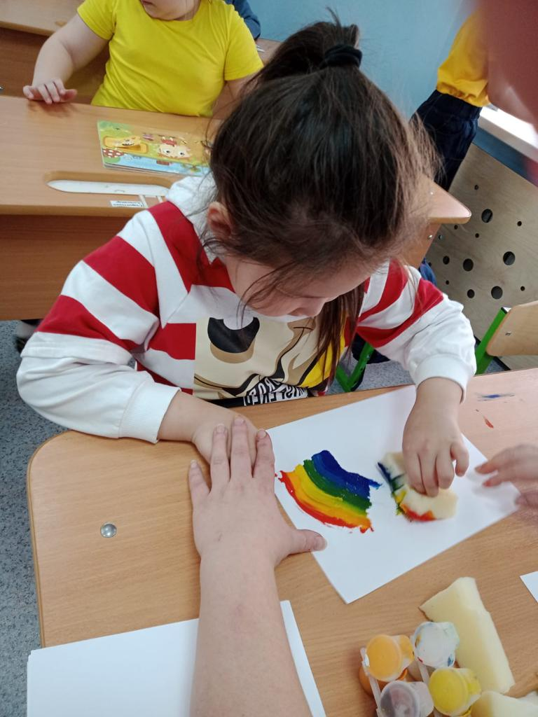

**Arsen B. (8 years old)**

Arsen attends the preparatory group of the kindergarten. Arsen is a very active boy, loves to play hide and seek and other active games. Arsen tries hard in class, but it is difficult for him to maintain attention for a long time. The boy has yet to master self-regulation skills. His favorite activity is sensory integration. Since September 2023, Arsen has moved to a state rehabilitation center for children with special needs.

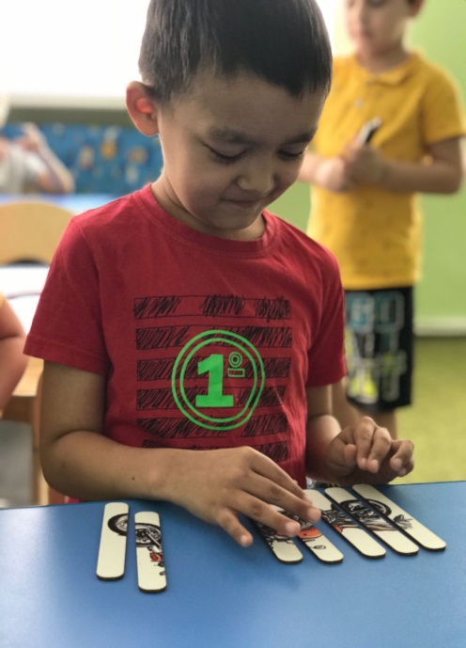 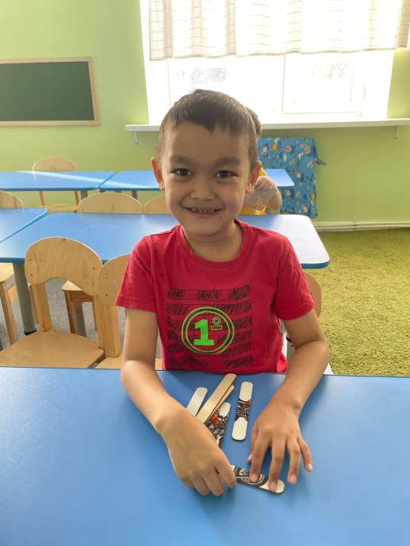 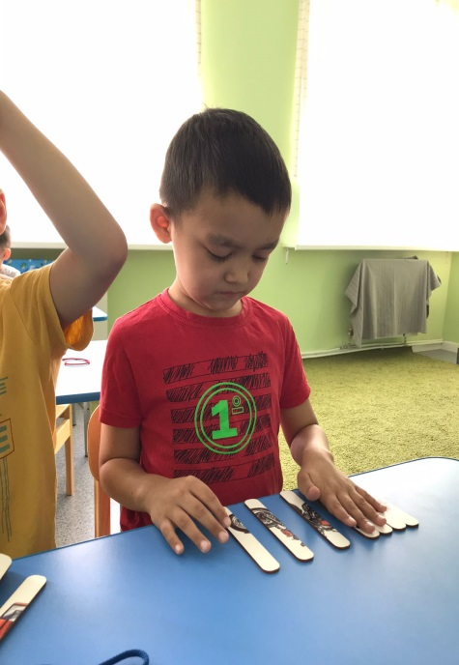

**Kira G. (5 years old)**

Kira is a special child from a large family. She has been attending classes on an individual schedule since October 2022. She has a rare genetic pathology of internal organs, so the girl’s mother is very worried about her health. Kira completed a full year-long rehabilitation course and during this time achieved great success. There has been great progress in speech, the speech therapist praises Kira very much. During her time in the pool, Kira learned to swim and dive. Her academic skills have improved significantly. (5 лет )

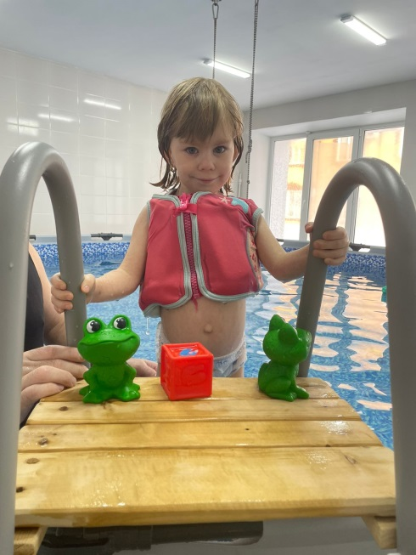 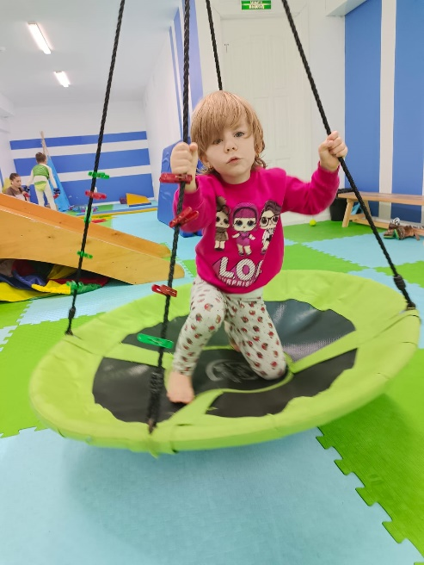 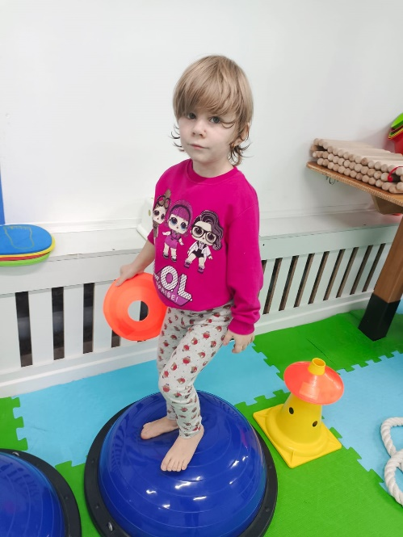

**Egor K. (7 years old)**

Egor is under the care of his aunt; he lost his mother in infancy. The boy has been attending kindergarten since September 2022. During the year of rehabilitation, Egor made significant progress in his skills, he began to repeat some words, and his understanding of speech improved. Perseverance has appeared, henow goes to classes with pleasure, his favorite teacher is a psychologist - Sergei Arturovich, Egor always looks forward to his classes and tries very hard.

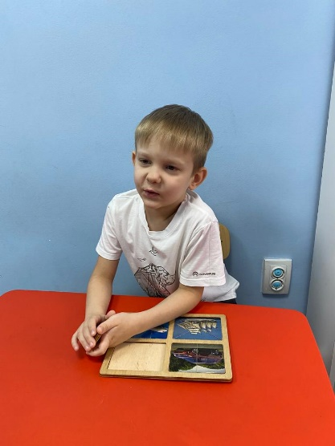 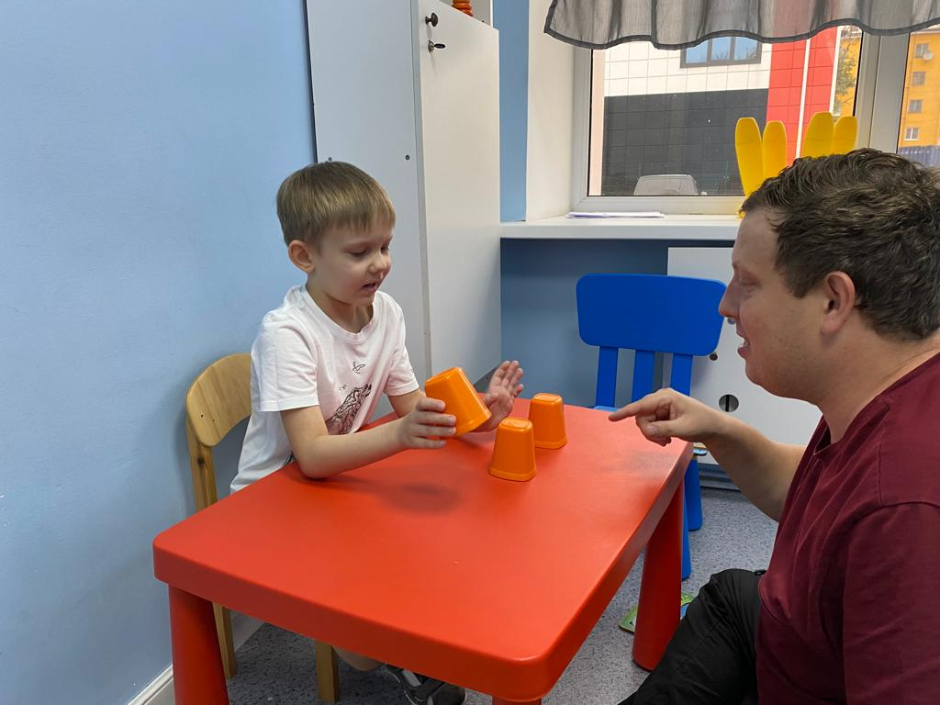 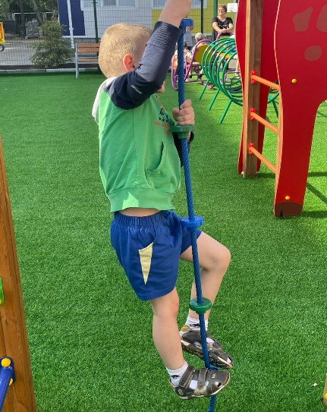

**Kuzma E. (9 years old)**

Kuzma is 9 years old and has a rare genetic disease associated with a lack of growth hormone. Kuzma is the third child with a disability in the family. The boy attends classes at the center according to an individual program; he works with an exercise therapy instructor, a speech therapist and a speech pathologist. Kuzma goes to classes with great pleasure. From September 2023, Kuzma went to the first grade of the Special School-Kindergarten “Wonderland” for home-based education according to an individual program. Kuzma’s mother is very pleased with her son’s success and looks forward to his future.

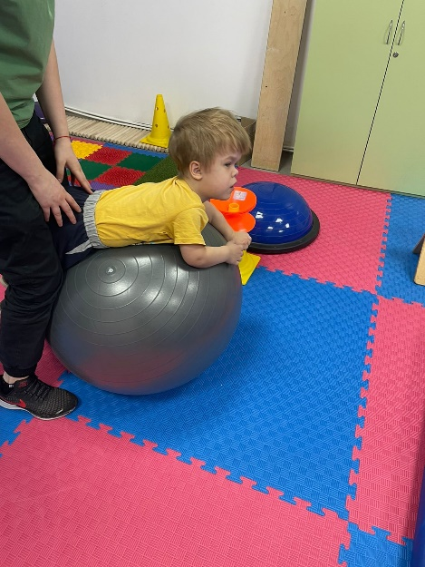 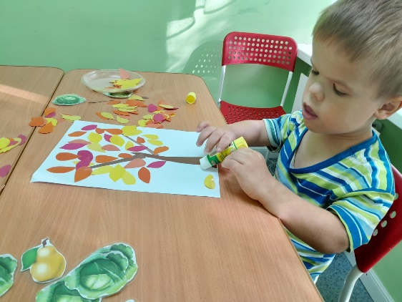 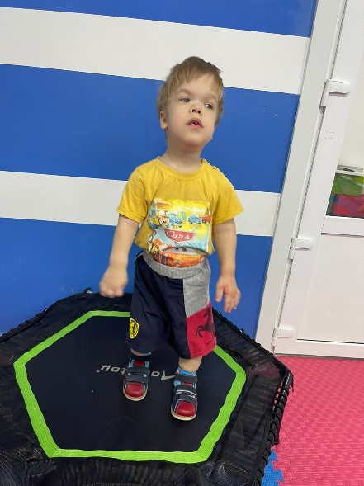

**Yaroslav Sh. (6 years old)**

Yaroslav has been attending the kindergarten preparatory group since September 2022 and is preparing to go to school. Yaroslav is a diligent and obedient boy, he can already read and write, and most of all he likes to play with educational toys and put together puzzles. Yaroslav attends a dance club and loves to work out in the sensory integration room. Yaroslav is a very capable boy, despite the unwanted behavior that psychologists at our center successfully combat. From September 2023, the boy moved to grade zero and next year he will move to a comprehensive school.

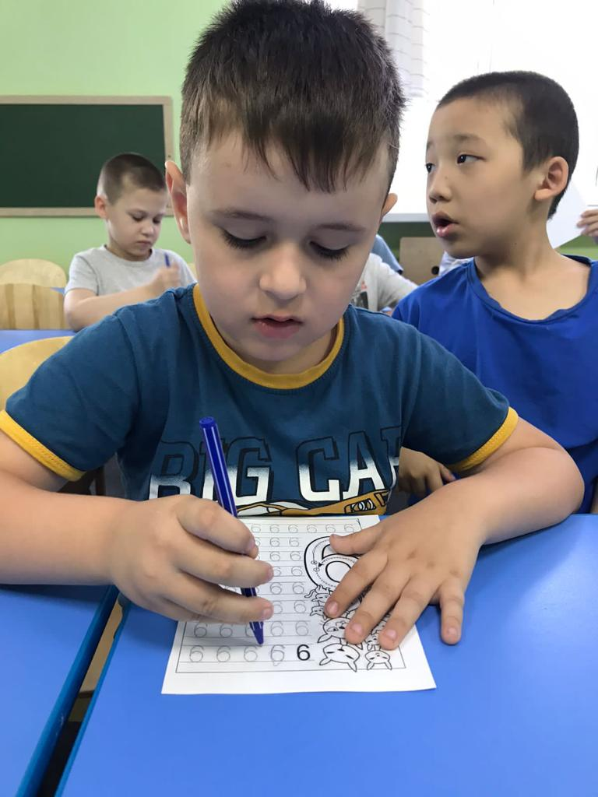 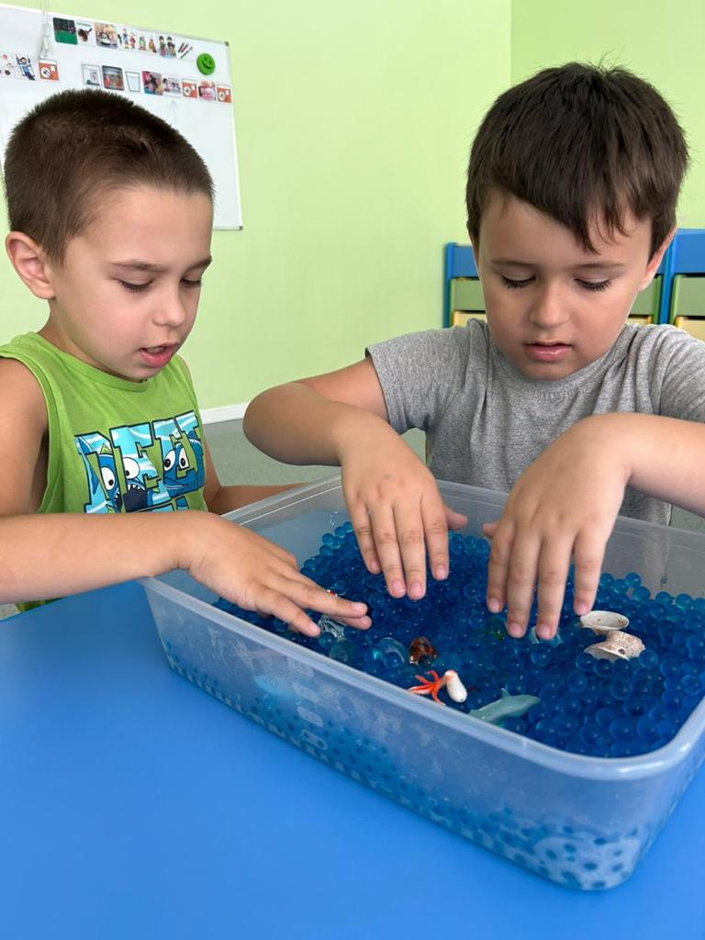 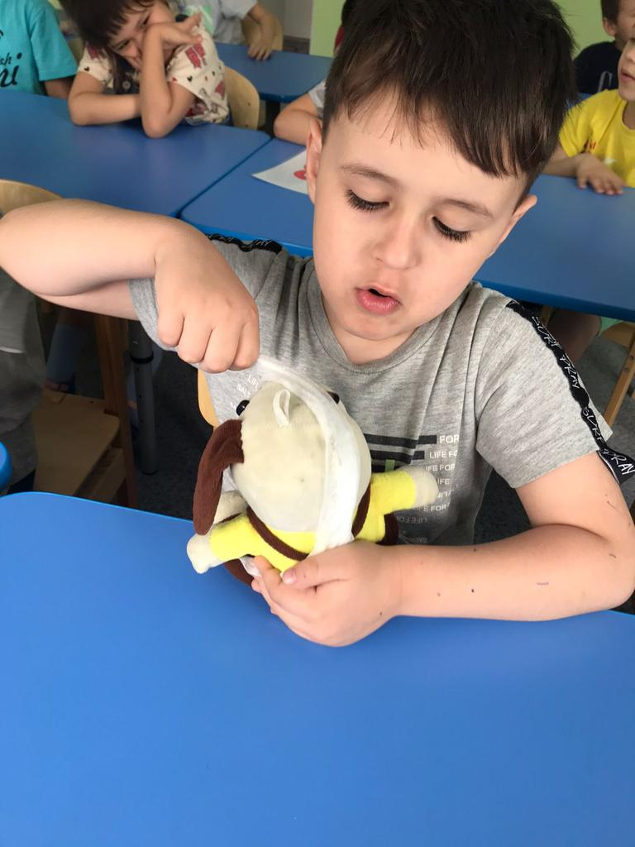

**Aibek B. (6 years old)**

Aibek has been attending kindergarten since September 2022, and it can be difficult for him to study and follow instructions, since he has not attended any preschool before. He is a very active kid, loves outdoor games and exercise therapy; Aibek likes swings most of all. From September 2023, Aibek moved to the preparatory group of the kindergarten. The boy has made significant progress in the development of his skills; he began to better understand spoken speech and learned to color and assemble puzzles. Aibek's favorite activity is sensory integration.

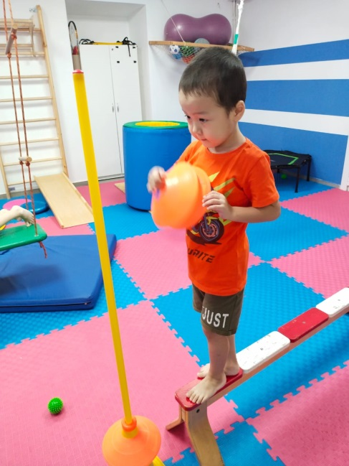 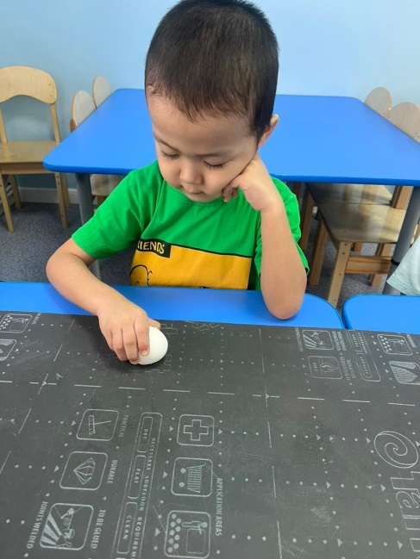 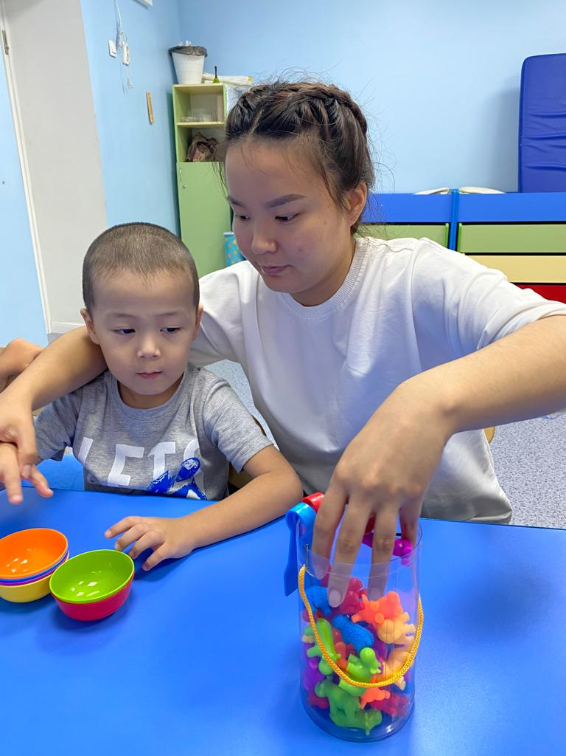

**David B. (5 years old)**

David has been attending kindergarten since May 2023. David has a younger brother, Samuel, who also has developmental disabilities. David adapted quickly enough to kindergarten and he really enjoys attending classes. The boy especially enjoys pool activities and sensory integration.

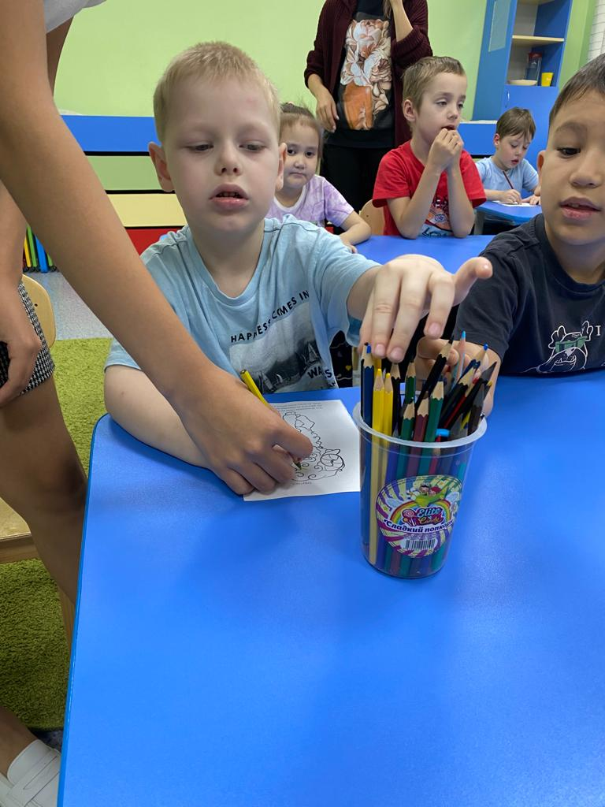 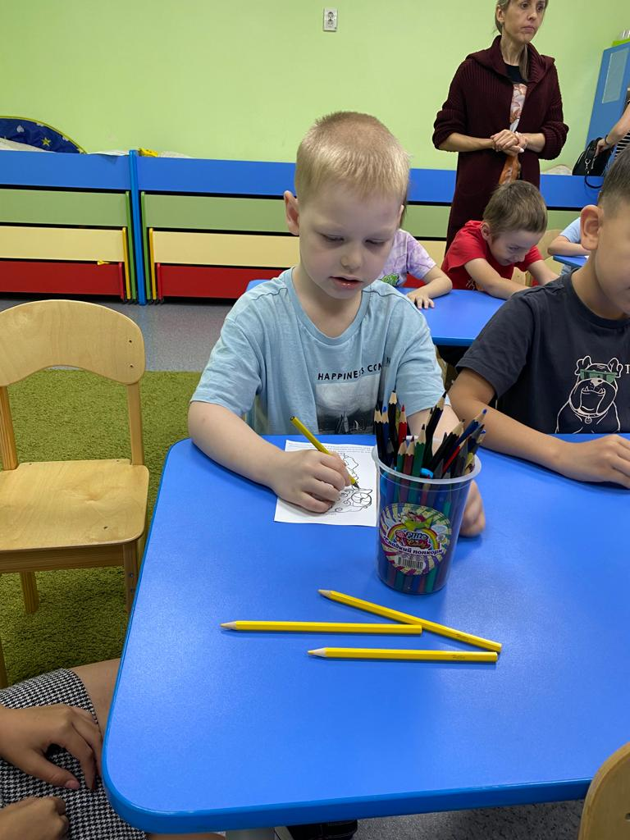 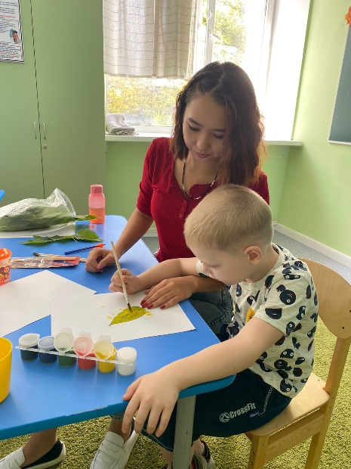

**Arlan K. (4 years old)**

Since September 2022, Arlan has been studying on an individual schedule with a speech pathologist, psychologist, exercise therapy specialist and visits the pool. The boy is preparing to go to kindergarten, for this he needs to master the primary skills of self-regulation, get used to the center’s specialists and adapt. He is already making great progress; he has learned to sit at a table, follow instructions from specialists, and study regularly. From May 2023, Arlan moved to a regular kindergarten.

